https://microservices.io/articles/applying.html

https://stackify.com/what-are-microservices/

https://www.edureka.co/blog/what-is-microservices/

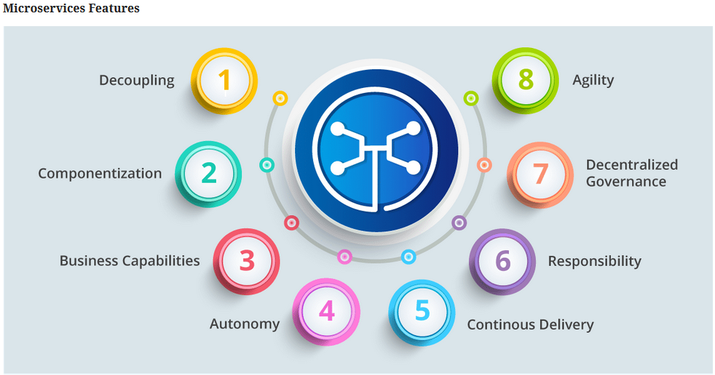

- Decoupling – Services within a system are largely decoupled. So the application as a whole can be easily built, altered, and scaled
- Componentization – Microservices are treated as independent components that can be easily replaced and upgraded
- Business Capabilities – Microservices are very simple and focus on a single capability
- Autonomy – Developers and teams can work independently of each other, thus increasing speed
- Continous Delivery – Allows frequent releases of software, through systematic automation of software creation, testing, and approval
- Responsibility – Microservices do not focus on applications as projects. Instead, they treat applications as products for which they are responsible
- Decentralized Governance – The focus is on using the right tool for the right job. That means there is no standardized pattern or any technology pattern. Developers have the freedom to choose the best useful tools to solve their problems
- Agility – Microservices support agile development. Any new feature can be quickly developed and discarded again

Advantages Of Microservices

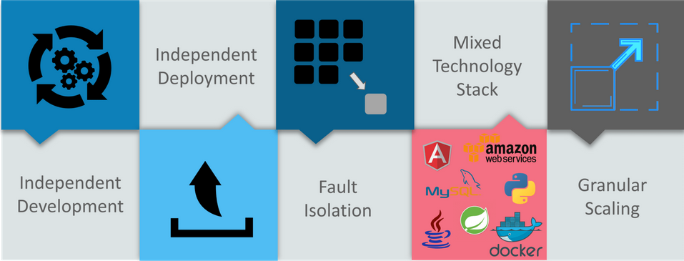

- Independent Development – All microservices can be easily developed based on their individual functionality
- Independent Deployment – Based on their services, they can be individually deployed in any application
- Fault Isolation – Even if one service of the application does not work, the system still continues to function
- Mixed Technology Stack – Different languages and technologies can be used to build different services of the same application
- Granular Scaling – Individual components can scale as per need, there is no need to scale all components together.

Best Practices To Design Microservices
In today’s world, complexity has managed to creep into products. Microservice architecture promises to keep teams scaling and function better.
The following are the best practices to design microservices:
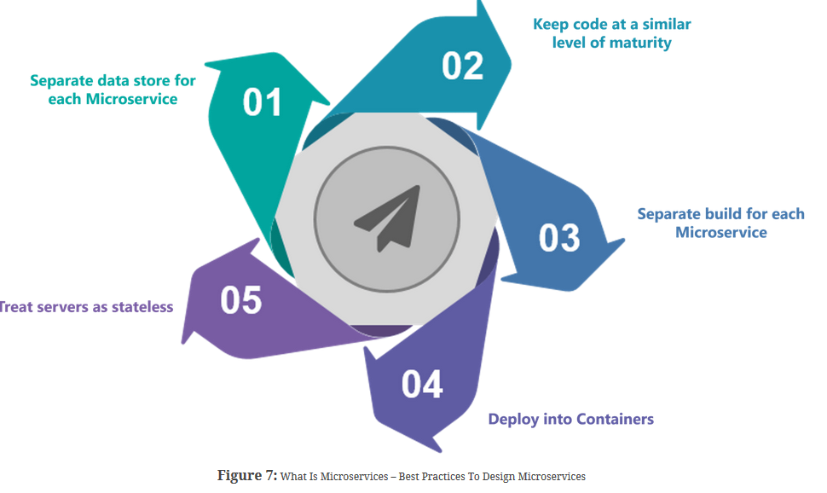

Use Case.

Use-Case: Shopping Cart Application
Let’s take a classic use case of a shopping cart application.
When you open a shopping cart application, all you see is just a website. But, behind the scenes, the shopping cart application has a service for accepting payments, a service for customer services and so on.
Assume that developers of this application have created it in a monolithic framework Refer to the diagram below:
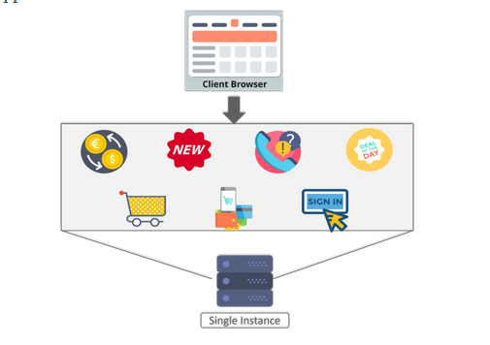

So, all the features are put together in a single code base and are under a single underlying database.
Now, let’s suppose that there is a new brand coming up in the market and developers want to put all the details of the upcoming brand in this application.
Then, they not only have to rework on the service for new labels, but they also have to reframe the complete system and deploy it accordingly.
To avoid such challenges developers of this application decided to shift their application from a monolithic architecture to microservices.Refer to the diagram below to understand the microservices architecture of shopping cart application

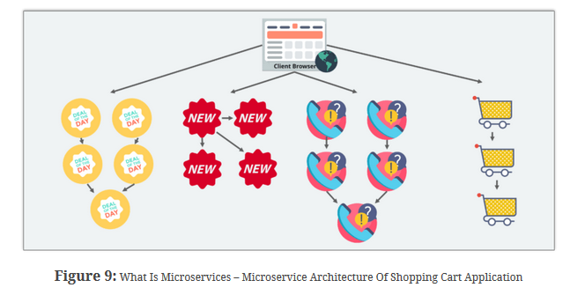

Companies using Microservices
There is a long list of companies using Microservices to build applications, these are just to name a few:
Amazon,Netflix,ebay,

